Pepper Leftovers

[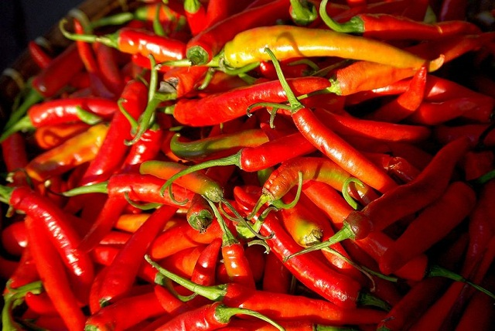](https://balconygardenweb-lhnfx0beomqvnhspx.netdna-ssl.com/wp-content/uploads/2016/06/pepper-in-garden.jpg)

Use the leftovers from peppers, such as seeds and the tops to keep garden pests in away. Blend the waste, strain, mix with water in a spray bottle and use the spray to deter pests from your plants.